REVISIONS:
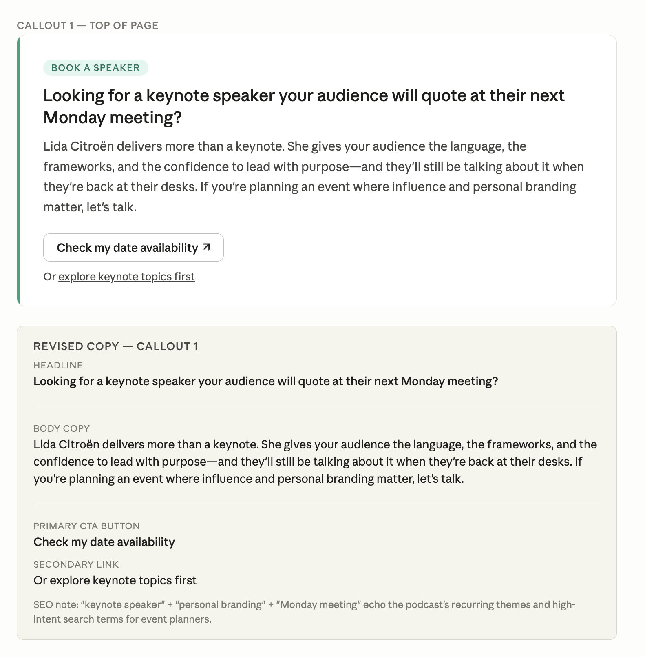

(CHECK MY DATE AVAILABILITY)
I want to book Lida Citroën as a keynote speaker. What are the next steps?

Claude responded: To book Lida as a keynote speaker, your best next steps are:
To book Lida as a keynote speaker, your best next steps are:
- Visit her speaking page at lida360.com/speaking — her Speaker Kit is available there as a PDF, which gives you topics, bio, and credentials to share with your event committee.
- Reach out directly via her contact page at lida360.com/contact-lida or email her team at Lida@LIDA360.com — that's the address listed on her site.
- Have these details ready when you reach out — it'll speed things along:
  - Your event date, location, and format (in-person, virtual, hybrid)
  - Audience size and professional profile
  - Topic focus (personal branding, executive presence, influence, reputation, military transition, etc.)
  - Your budget range
- Download her Speaker Kit directly from her site to share with stakeholders while you wait to hear back.
Lida's calendar fills up, so the sooner you reach out the better — especially if you have a firm event date in mind.
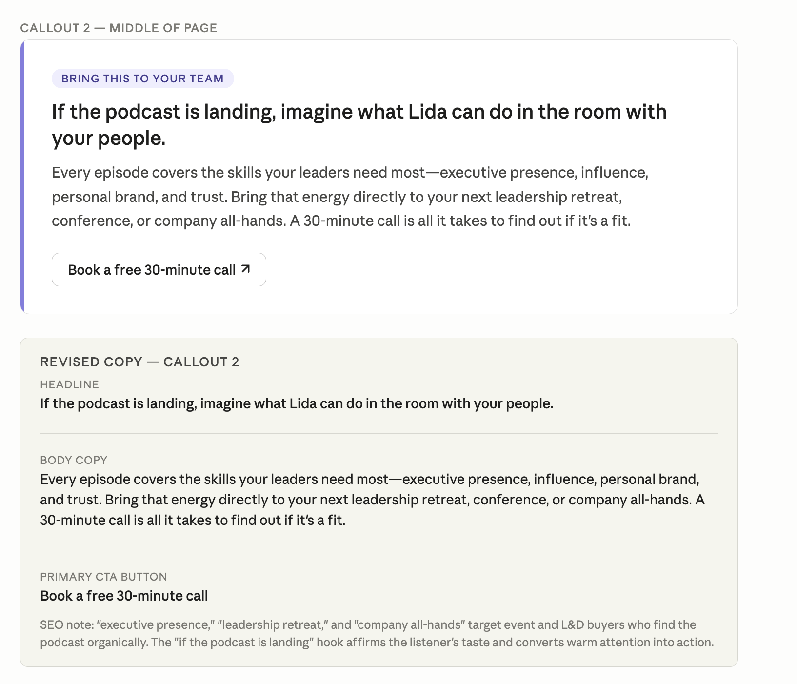
Book a 30-min free call goes to:
I'd like to book a discovery call with Lida Citroën about speaking at my company event.

Great move — a discovery call is the fastest way to find out if it's a fit. Here's how to make it happen:
Schedule or request your call:
- Email: Lida@LIDA360.com
- Contact form: lida360.com/contact-lida
In your message, mention that you're requesting a 30-minute discovery call about a speaking engagement — that framing helps her team route and prioritize your inquiry correctly.
To make the most of the call, come with:
- Your event date and format
- A quick description of your audience (industry, seniority level, size)
- The problem you're trying to solve or the outcome you want for attendees
- Any budget parameters, if you're ready to share them
Before the call, it's worth skimming:
- Her Speaker Kit so you already know her topic areas
- A couple of podcast episodes relevant to your audience — it gives you great talking points about why she's the right fit for your specific crowd
The call itself is low-pressure. Think of it as a mutual fit conversation — you're evaluating her as much as she's evaluating the engagement. Go in curious, not just shopping.

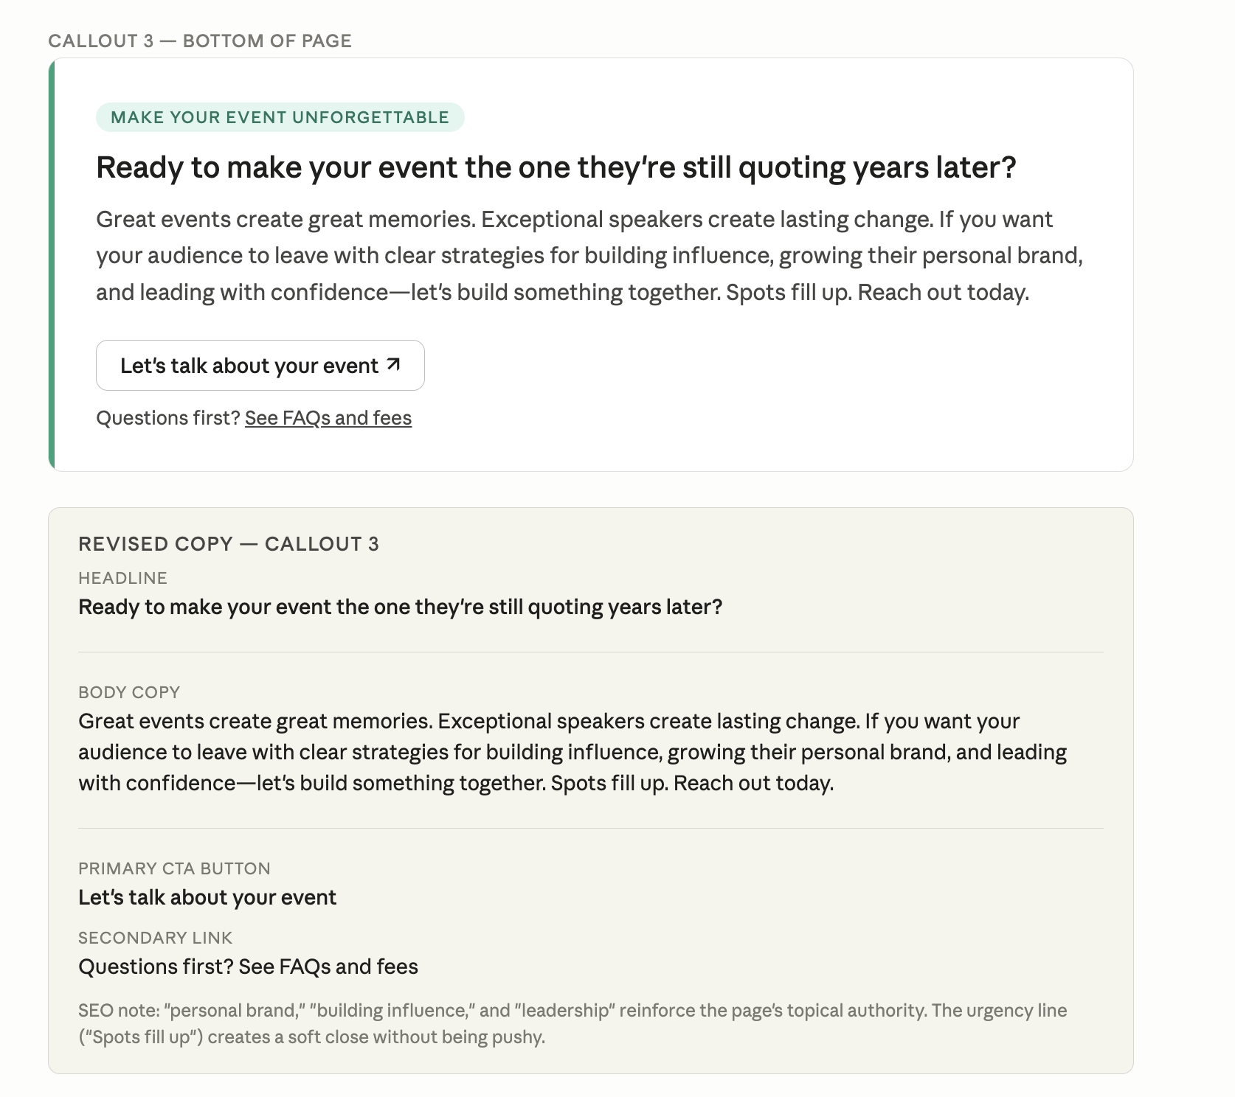

You said (LET’S TALK ABOUT YOUR EVENT)

Claude responded: Same path as booking a keynote — here's how to get the ball rolling:
Same path as booking a keynote — here's how to get the ball rolling:
Contact Lida directly:
- Email: Lida@LIDA360.com
- Contact form: lida360.com/contact-lida
Come prepared with the basics:
- Event date, location, and format (in-person, virtual, or hybrid)
- Audience size and who they are (executives, veterans, emerging leaders, association members, etc.)
- The outcome you want — what should your audience walk away knowing or doing differently?
- Your budget range
Helpful resources to explore first:
- Speaker Kit (PDF) — topics, bio, and credentials to share internally
- Speaking page — overview of her keynote themes
- Media page — past appearances and press, useful for making the case to stakeholders
The more context you give upfront, the faster she can confirm whether it's a fit and get you a proposal. And since her calendar fills quickly, reaching out sooner rather than later is always the right move.

